# Karyawan

## Karyawan Save

## Karyawan Update

## Karyawan List

## Karyawan Get ID

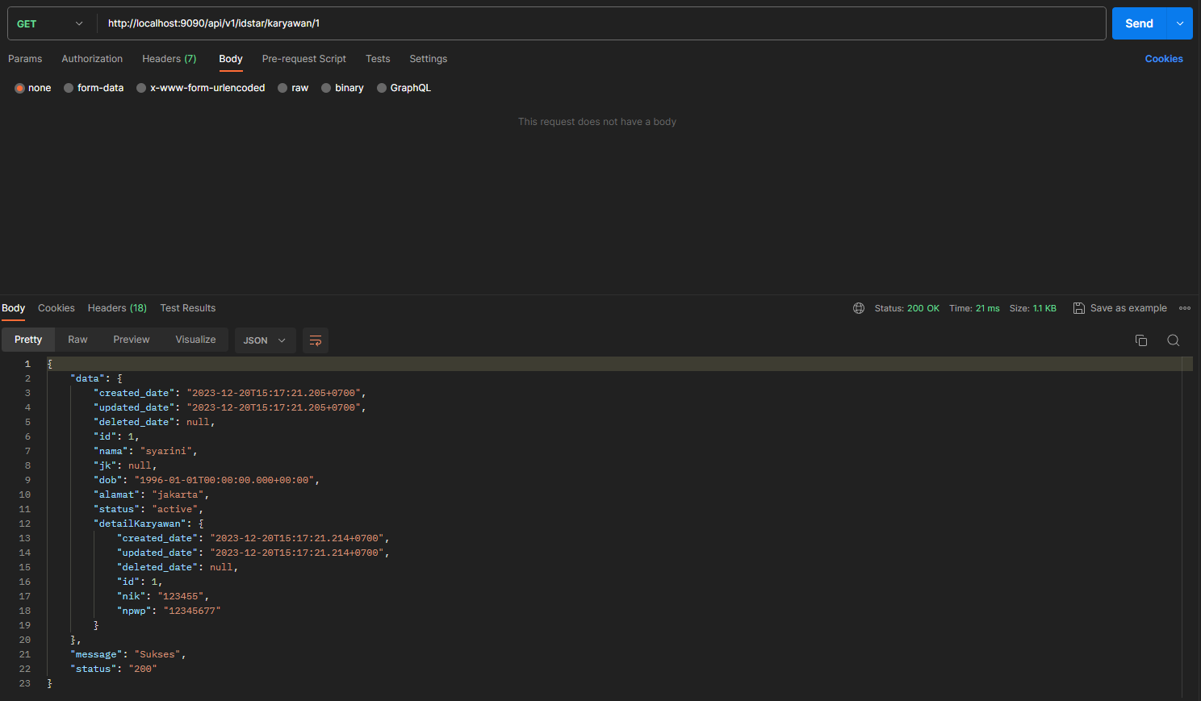

## Karyawan Delete

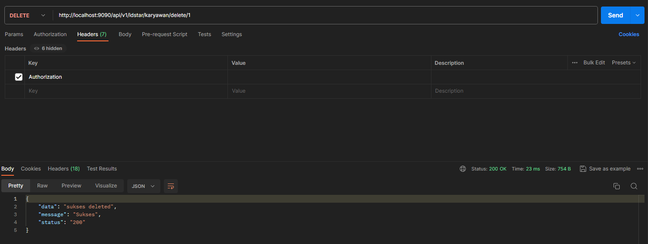

# Rekening

## Rekening Save

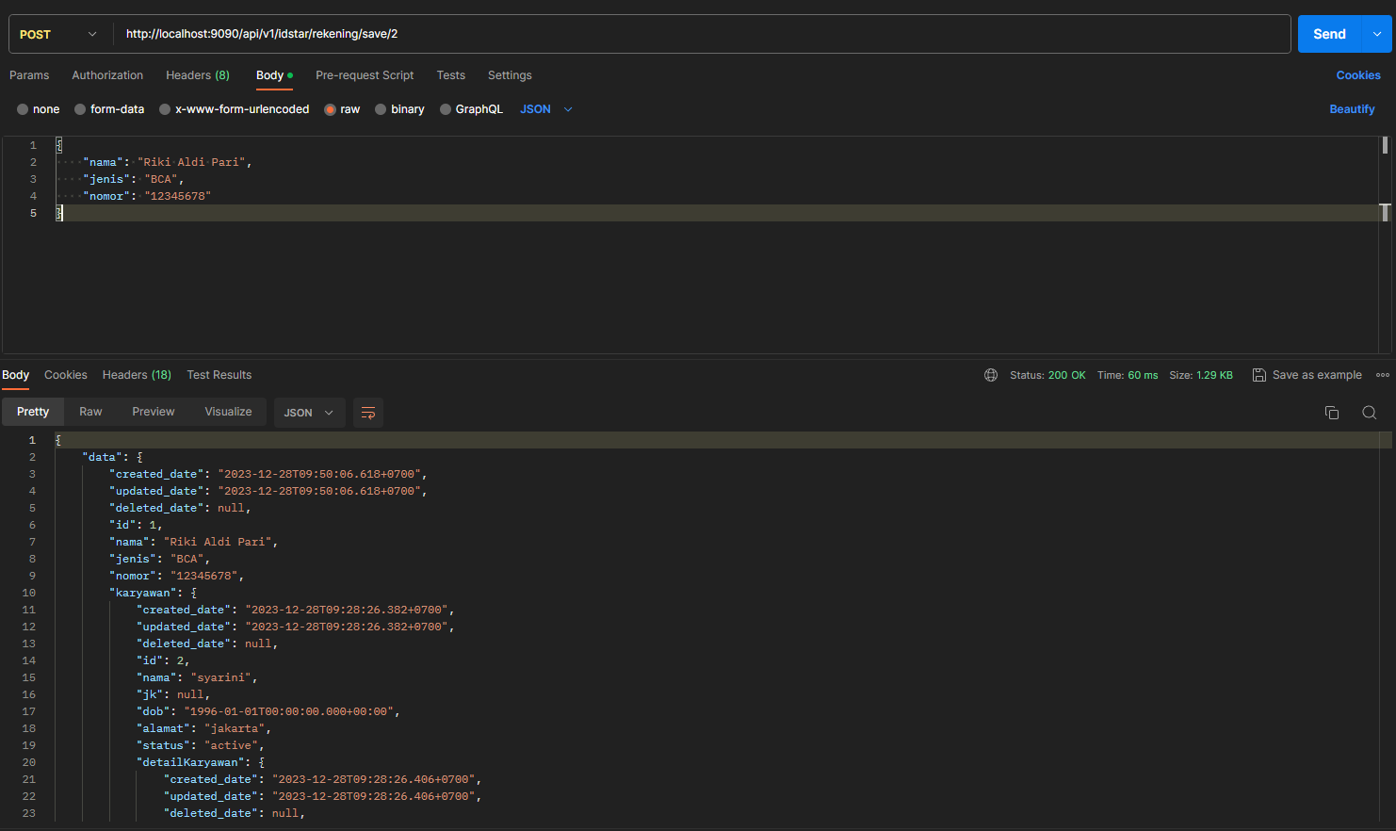

## Rekening Update

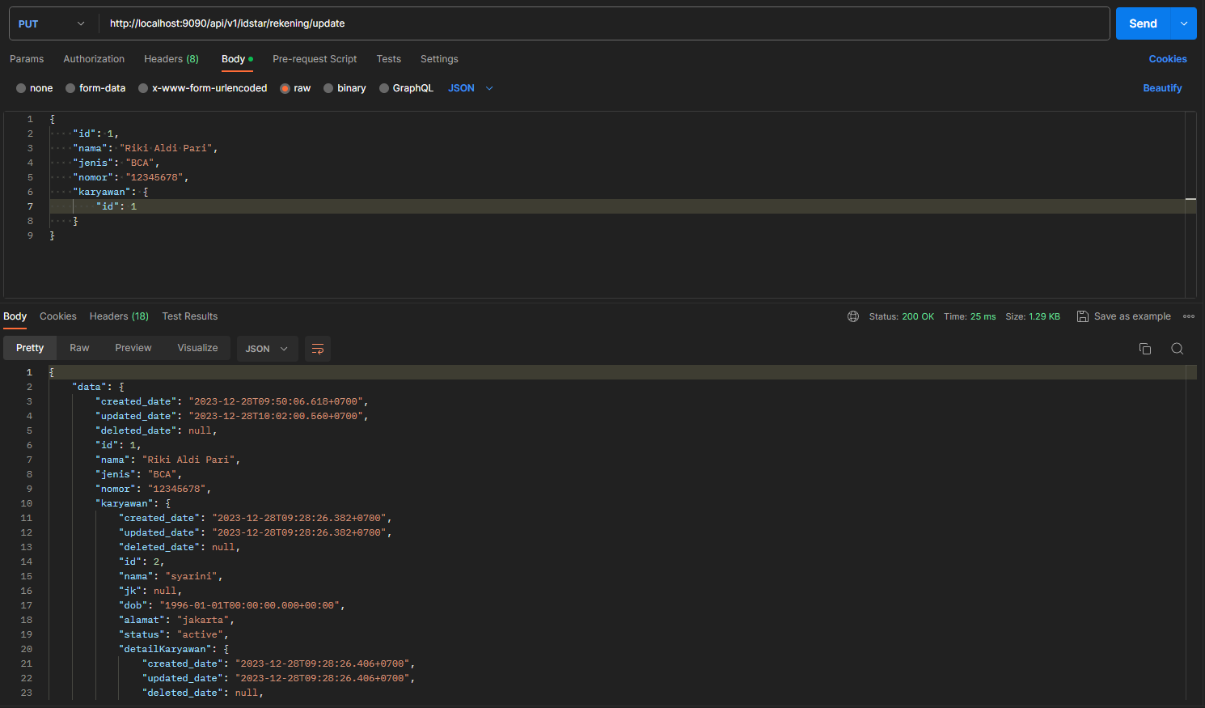

## Rekening List

## Rekening Get ID

## Rekening Delete

# Training

## Training Save

## Training Update

## Training List

## Training Get ID

## Training Delete

# Karyawan Training

## Karyawan Training Save

## Karyawan Training Update

## Karyawan Training List

## Karyawan Training Get ID

## Karyawan Training Delete

